1. **SSB data**

SSB is the official statistics of Norway. You can get a lot of information from here. However, I guess most of you will work with import or export data. Then the link is given as flowing. Since it is pretty easy and straightforward to download the SSB data. I will not extend the discussion on how to use the data here.

[**https://www.ssb.no/statistikkbanken/selecttable/hovedtabellHjem.asp?KortNavnWeb=muh&CMSSubjectArea=utenriksokonomi&checked=true**](https://www.ssb.no/statistikkbanken/selecttable/hovedtabellHjem.asp?KortNavnWeb=muh&CMSSubjectArea=utenriksokonomi&checked=true)

1. **Eurostat trade data**

If you want to work with the EU import market (can be one of the EU members), you can try this link to Eurostat dataset. Here is an example how to access to trade data.

<http://epp.eurostat.ec.europa.eu/newxtweb/>

If I click this link, chose EU trade since 1988 by CN8 (you are free to select data by yourselves), I get the following pasted dataset. Click the “+” button just beside product-total, you get data in very detail, products associate with the Combined Nomenclature (CN), which corresponds to the Harmonized System (HS) plus a further breakdown at 8-digit Level; You can work with more aggregated level by just extending the product tree less, not until 8-digit.

Chose flow as import, since import is a derived demand from the EU consumption. You can click the right button “+” beside reporter to select the country and region (market) that you want to analyze, for example, French import market; You can click “+” beside partner to specify where the goods come from, e.g., US; Click “+” beside indicators to get volume and price; Click “+” beside period to choose the sample periods; The presentation of the table can also be changed according to your preferences. I hope you will investigate a little bit more by yourselves.

DS-016894

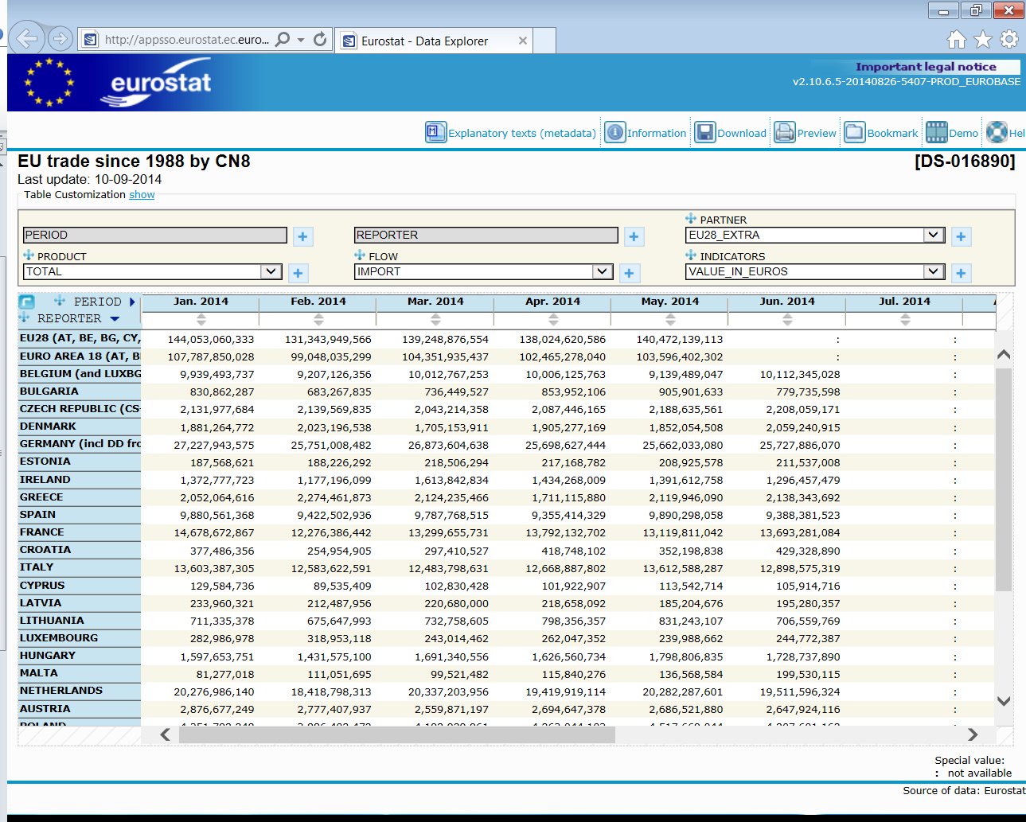

1. **International Trade Committee (ITC) US**

If you want to work with the USA import market, you can try this link to ITC data. <http://dataweb.usitc.gov/>

You have to create a user name and login in by your user name. It is free and takes only one or two minutes.

**Step 1**: select U.S import for consumption since this data is most close to consumer demand. Choose HTS items, since US has many different versions of data.

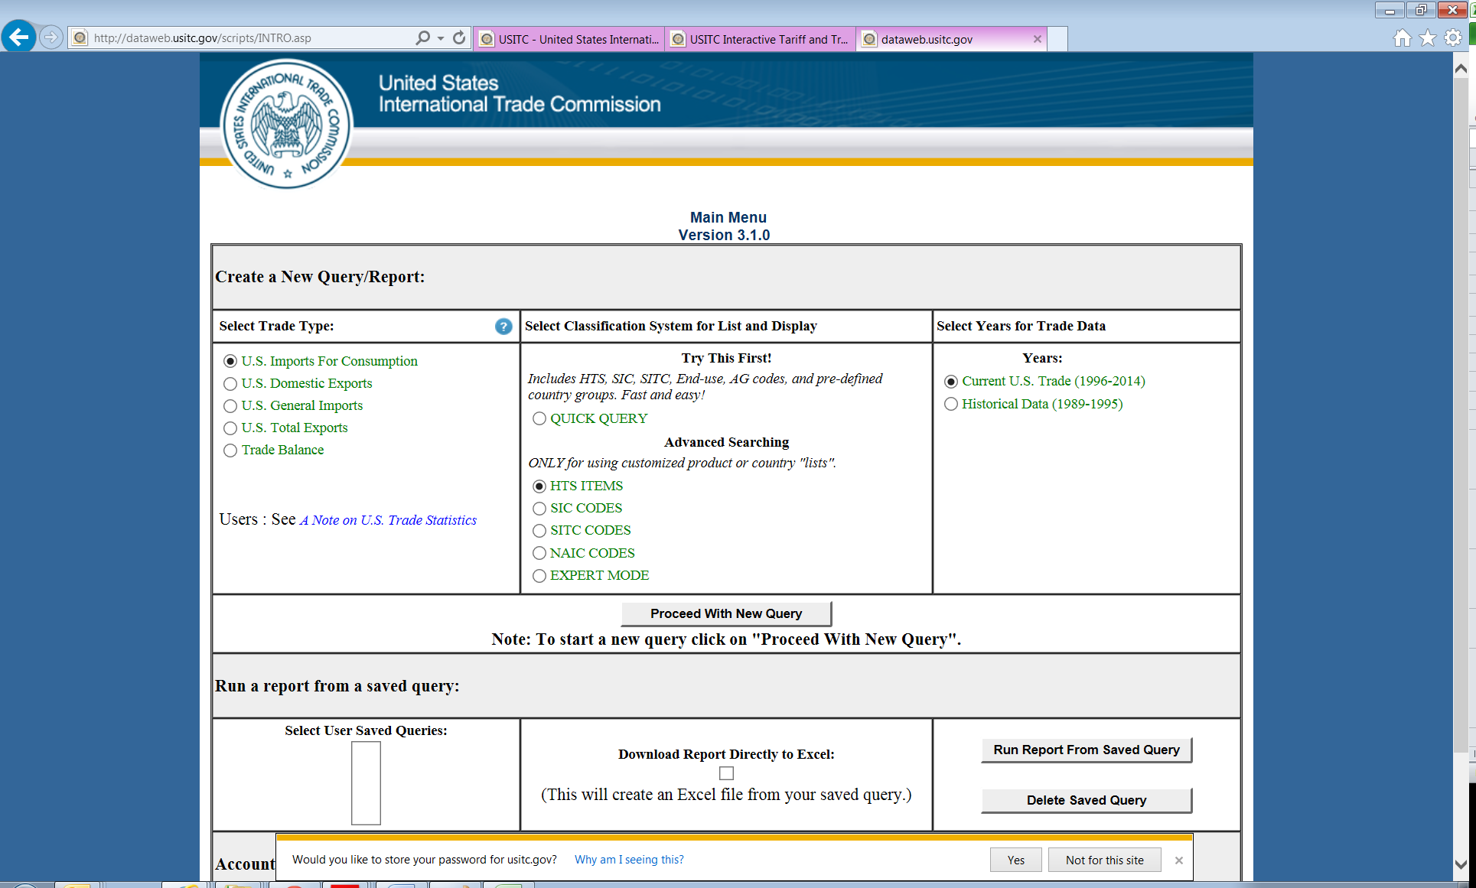

**Step 2:** Select the data to report both first unit of quantity and CIF import value, price can be computed by Value/quantity. Select aggregate level of HTS-6, since HTS-2 and HTS-4 cannot provide monthly or quarterly data. Keep all the options in an aggregate level unless you have your own specific interesting.

Most tricky thing is “Select All Commodities or a Pre-Defined List”, click “Create a New Commodity List” and then we go to Step 3.

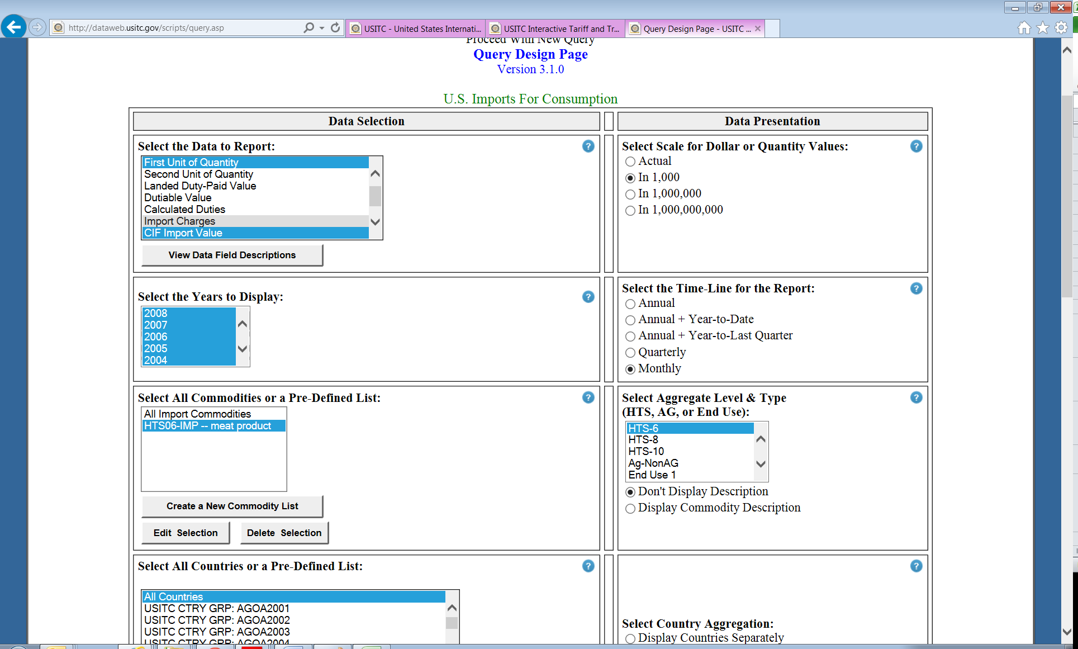

**Step 3:** In the “Enter the new list name”, you type the commodity group that you like. For example here, I typed meat product, and named it as the meat product (or another name you like) in the right side. By doing that, you will get a list of meat products that you would like to include**.**

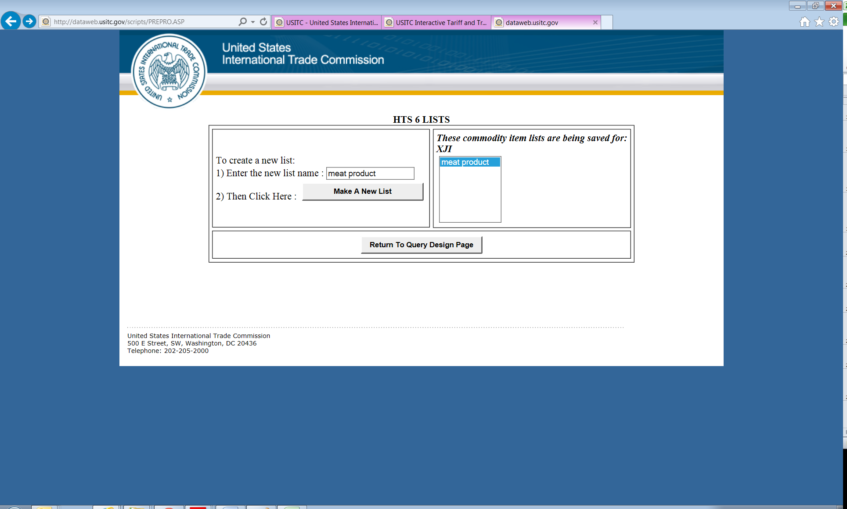

**Step 4:** Clike Download Report Directly to Excel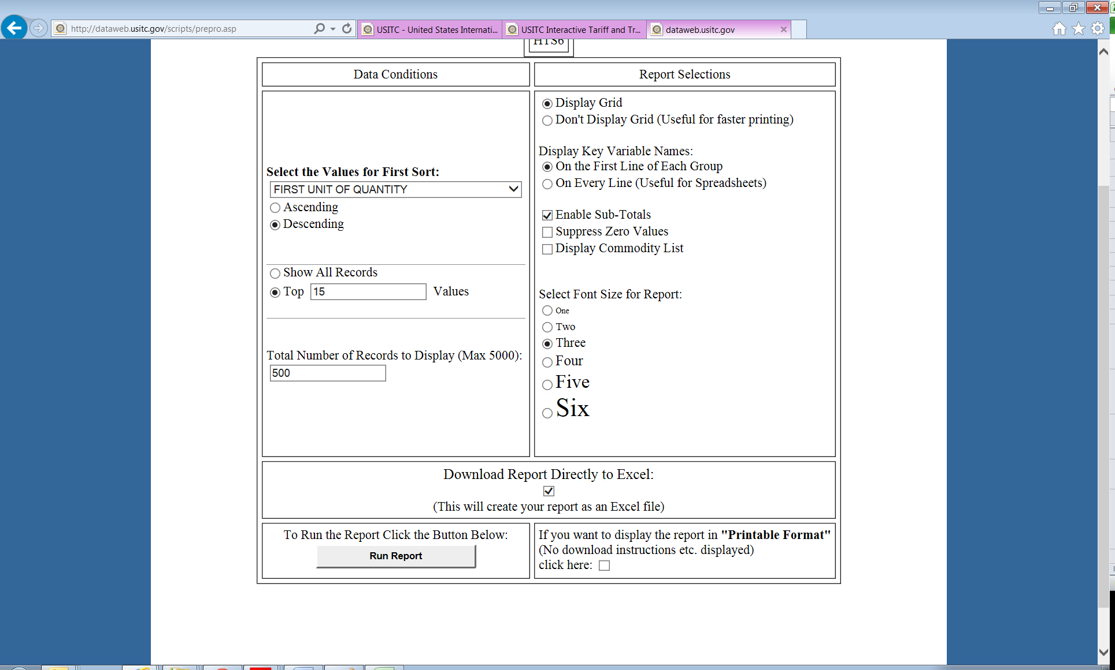

**You get the data in excel form:**